Lab 13 Data Storage and Analysis
Student: Toleubek Assiya
ID: 23B150271

Task 1: Create an S3 Bucket with Versioning
- Create a new S3 bucket with a globally unique name (e.g., yourname-data-lake-lab)
- Region: eu-north-1
- Enable versioning on the bucket
- Enable default encryption (SSE-S3)
- Block all public access (default)
Deliverable: Screenshot of bucket properties showing versioning enabled.
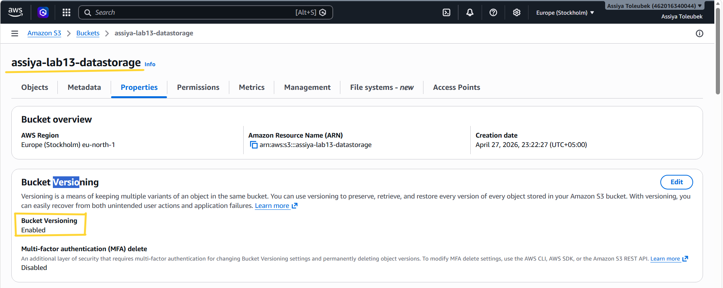

Task 2: Upload and Download Files Using AWS CLI
Using the AWS CLI, complete the following:
- Create a local text file named test.txt with content "Hello Cloud Storage!"
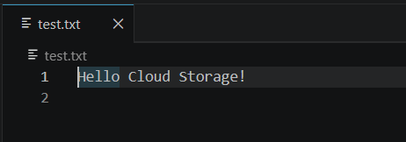
- Upload the file to your bucket under key data/test.txt
- Upload a second file (any image or CSV) to data/sample.csv
- List all objects in the data/ prefix
- Download both files to a local folder named downloaded/
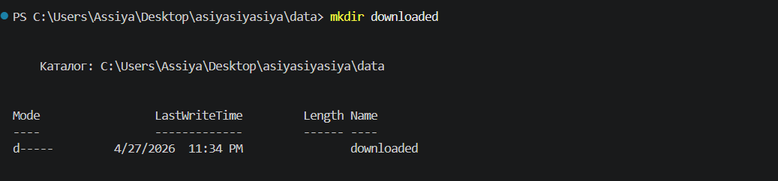
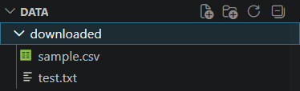
Deliverable: Paste the terminal commands and output (screenshot or text).

Task 3: Python boto3 – Upload, Download, List, Delete
Write a Python script named s3_operations.py that does the following:
- Creates an S3 client using boto3
- Uploads a file named report.csv (create this file with any sample data) to your bucket with key uploads/report.csv
- Adds custom metadata to the object: {"department": "analytics", "owner": "yourname"}
- Downloads the file to downloaded_report.csv
- Lists all objects in the uploads/ prefix and prints their keys, sizes, and last modified dates (handle pagination properly)
- Generates a presigned URL for uploads/report.csv valid for 2 hours and prints the URL
- Deletes the object uploads/report.csv after verifying it exists
Deliverable:
- Python script file (s3_operations.py)
- Screenshot of the script output (showing the presigned URL and list of objects)
import boto3

bucket_name = "assiya-lab13-datastorage"
s3 = boto3.client('s3')

with open("report.csv", "w") as f:
f.write("id,value\n1,100\n2,200")

s3.upload_file(
"report.csv",
bucket_name,
"uploads/report.csv",
ExtraArgs={
"Metadata": {
"department": "analytics",
"owner": "assiya"
}
}
)

print("Uploaded")

s3.download_file(
bucket_name,
"uploads/report.csv",
"downloaded_report.csv"
)

paginator = s3.get_paginator('list_objects_v2')
for page in paginator.paginate(Bucket=bucket_name, Prefix="uploads/"):
for obj in page.get("Contents", []):
print(obj["Key"], obj["Size"], obj["LastModified"])

url = s3.generate_presigned_url(
"get_object",
Params={"Bucket": bucket_name, "Key": "uploads/report.csv"},
ExpiresIn=7200
)
print("URL:", url)

s3.delete_object(Bucket=bucket_name, Key="uploads/report.csv")
print("Deleted")

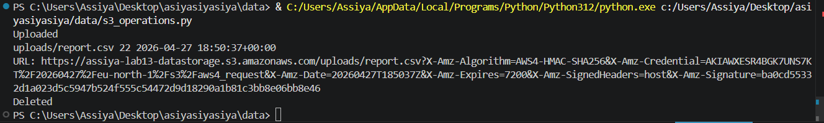

Task 4: Enable Lifecycle Policy
Create a lifecycle policy for your bucket that:
- Moves objects in the archive/ prefix to S3 Standard-IA after 30 days
- Moves the same objects to S3 Glacier Flexible Retrieval after 90 days
- Permanently deletes objects after 365 days
You can apply this policy using the AWS Console (easiest) or via CLI/JSON.
Deliverable: Screenshot of the lifecycle policy rules as shown in the AWS Console.
